**Determinants of Debt Levels by Cities in Iowa**

Daniel Otto and Michael Hudak

**Introduction**

The deep and extended recession of 2008-09 has been a very difficult event for state and local governments. State governments have been especially hard hit as the recession pounded their major sources of revenues. Declines in employment, wages and salaries, profits, and capital gains dramatically lowered tax receipts from income, sales and corporate taxes. At the same time the high unemployment levels increased demand for publicly financed medical care, unemployment insurance and other public services. Because of balanced budget requirements, most states governments responded by cutting numerous programs and reducing workforces.

Compared to state governments, local government’s tax revenues have held up fairly well because of their reliance on property tax revenues. While real estate values have plummeted or stagnated in many markets, the lag in converting changes in assessments into tax bills and reluctance to move assessments downward has spared many local governments losses from this revenue source for the present. Also, the local government budgeting process allows many local jurisdictions the option of raising rates to meet revenue requirements.

Some of the fiscal pressures of state and local governments have been temporarily relieved by federal stimulus fund aid to assist with Medicaid and education funding. Despite Federal stimulus assistance, local governments have been making dramatic spending cuts in the aftermath of the 2008 recession (Fisher 2010). In addition state and local governments are cutting capital expenditures in an effort to control costs. A reason given for the reduction is some of the local projects are funded through general obligation bonds with the debt servicing coming out of operations funds. If general operation funds become scarcer, additional needed infrastructure projects may become more difficult to implement. Downgrading the federal government’s credit rating to AA+ by S&P may also raise local governments borrowing costs.

In addition to affecting revenue for current year operations, the recession and fiscal stress is threatening the capacity for state and local government to issue debt to finance capital improvements and necessary infrastructure investments. Declines in property values in severely affected regions could affect tax capacity for servicing debt or compete with using property tax revenues for covering operating expenses. Cities have faced these fiscal crises in prior recessions as well. Other cities in rural agricultural regions have faced longer term continuous decline and fiscal stress as they depopulate. How have these cities responded? Have they continued to invest in capital improvement projects, and are there lessons for urban centers in their experiences? This paper investigates how rural communities in Iowa have responded to the threat of increased fiscal stress on their ability to use property-tax backed debt obligations at this stage of 2008 economic recession and recovery.

**Previous research**

Issues of local government fiscal stress is regularly monitored and reported on by important policy centers such as the Nelson A Rockefeller Center in Albany New York and the Center on Budget and Policy Priorities as well as the Federal Reserve Banks. Much of the previous research on government debt financing issues has focused on the state level. Research by Ellis and Schansberg (1999) used cross-section, time series data to study determinants of state government debt based on political, social and economic factors. A study by Wollf (2004) focused on structural and non-structural causes of debt for major US Cities. Their cross section of cities included a range of institutional settings that enabled a variety of local government responses. Our research focuses on how fiscal stress of the current recession is affecting rural communities in a single state allowing for a consistent set of political and institutional roles for city government. Etc.(more to come?)

**Role of GO debt in Iowa**

Some states limit the effects by having statutes on local government financing that restricts operating costs to a fixed levy cap. In Iowa this rate is $8.10 per $1000 taxable valuation and any debt servicing obligation is separate from operations functions. A more significant fiscal issue for rural local governments in states like Iowa is the lack of growth --both population and tax base. Our research covers all Iowa cities with a focus on nonmetro communities under 100,000 population (the regression I used for 2010 did have Des Monies and Cedar Rapids, they don’t seem to effect the regression but if you need me to omit them that can be done)to see how the current recession and fiscal crisis is affecting their use of debt. About 50 percent of the revenue base for Iowa cities comes from property taxes with the percentage being higher for cities over 8,000 in population. Other revenue sources include local sales tax, licenses and fees and intergovernmental revenues (Figure 1). Intergovernmental aid accounts for a higher percentage of the budget in smaller communities.

When cities have capital projects as part of their civic function that requires more money than is available at the time, they can use the debt financing process to borrow money from other sources to meet these needs. There are generally three kinds of municipal debt financing. The first is called general obligation debt, which is borrowed money backed by the "full faith and credit" of the city's property tax base which means that the property taxpayers are obligated to repay that debt. The second is called revenue debt financing, which is borrowed money backed by the payments of city service users or a specific revenue source, such as electric, water, or sewer utility payments. And the third is called special assessment debt, which is borrowed money that is paid back by the owners of property that benefit from the improvement. General obligation debt usually has the lowest rate of interest and is typically considered the municipal debt with the least risk. Cities generally borrow money by issuing bonds or notes. As an alternative to the formal competitive sale of bonds or notes, however, Iowa law allows cities to "negotiate" the sale of notes pursuant to a "loan agreement.”

The Iowa Constitution states that “no city may become indebted in any manner, or for any purpose, in an amount exceeding five percent of the value of taxable property in the city.” The Iowa Supreme Court has ruled that this provision applies only to debt payable from property taxes. The Iowa General Assembly has enacted a statute which interprets this Constitutional provision to allow the calculation of a city's debt capacity against the 100% or actual valuation of property, rather than the taxable value which incorporates the "roll-back." Further, this limit applies only to outstanding principal amounts of debt. Accordingly a city’s sum total of outstanding loans, bonds, notes or other instruments payable from property taxes cannot exceed the principal amount of five percent of the actual valuation of the city. As a result of an Iowa Supreme Court decision, tax increment revenue debt must also be counted.

http://www.iowaleague.org/Downloads/Workshops/Materials/2010/Budget/InfoSheets.pdf

**Iowa Trend in General Obligation and debt service in current recession**

The level of debt held by local government in Iowa and backed by property taxes is presented in Figure 2 with recent per capita growth in that debt level presented in Figure 3. Cities are by far the largest holder of general obligation debt by local governments, followed by school districts and special districts. The rate of increase in GO debt by cities is about 5% between 2007 and 2009 (11.7% for 2007-2010) slightly less than the growth in property values which is about 8%(15.7% for 2007-2010). Over all Iowa cities, the average GO debt is within the 5% allowable tax capacity indicating addition capacity for bonding.

Detailing the per capita financial and debt information according to city size indicate a distinctive relationship to city size. Even after adjusting to a per capita basis, the level of general obligation debt increases as the size of city increases (Figure 4). Smaller cities in Iowa tend to have no commercial or industrial sectors and rely only on residential property tax base. Many of 392 Iowa cities under 500 population have limited city functions and do not incur GO debt resulting in a small average per capita debt level. The average per capita GO plus TIF debt levels range from about $600 for cities in the 500 to 2500 population range to roughly $1200 for cities in the 30,000 to 100,000 population range (Figure 5).

Other fiscal indicators follow a similar pattern of increasing percapita levels as city population increases. Per capita spending on governmental operations (Figure 6) increases from $600 for cities smaller than 500 to $1600 per capita for cities in the 10,000 to 30,000 population range. The fiscal capacity of cities as measured by tax base also increases by about 4 percent annually during this time period(Figure 7).

This profile of debt levels by Iowa cities during this recessionary period indicates that while debt obligations have increased, the bonding capacity which is limited to 5% of taxable values, is still growing during this time frame (Figure 8). On average, cities in each size category have actually increased the amount of bonding capacity available to them by the end of the period (Figure 9-12). On average for all sizes of cities, growth in tax base has kept pace with increases in debt obligations. A plot of per capita debt obligations against taxable values within cities (Figure 13) indicates a pattern of cities with larger tax bases having higher per capita debt levels with the highest values occurring in the high end of the range.

**A Model of Local government debt financing**

To measure the use of GO debt financing by local governments we define TGOTIFDEBT to be the sum of the outstanding per capita general obligation and TIF debt issued by the Iowa cities in our study. Both these types of loans are backed by the full faith and credit of local governments taxing authority. A second measure of local government capacity to use and handle GO debt was also used, and is defined as outstanding GO and TIF debt divided by the tax base in each city (GOTIF/TAX). This variable provides a measure of the property wealth of a community and its capacity to service additional GO debt.

The explanatory variables in the regression consist of measures and proxies for the major demographic, economic and political factors likely to affect levels of debt obligations by Iowa cities. PCT18 is the percentage of each cities population under 18 years of age and PCT65 is the percentage of each cites population over 65 years of age. These variables represent population groups that are sensitive to longer term capital investment policies. The elder population is anticipated to be more reluctant to adding to capital infrastructure and incurring further debt obligations. Cities with higher percentage of under 18 year olds are anticipated to be growing communities with infrastructure needs and willingness to make investments.

As a major part of the local tax base, housing characteristics are expected to be an important factors affecting GO bonding. PCTOWNOCC is the percent of owner occupied housing in the community and is a reflection of investment in homes and communities. Many of Iowa’s smaller communities have very limited rental housing units with predominantly an older housing stock occupied by older Iowans who are expected to be reluctant to commit to new GO bonding. In the expanding suburban communities around Iowa’s employment centers, higher levels of home ownership could be associated with rising city debt levels. Median housing value in the community, MEDHVAL tends to be higher in growing communities with newer housing. This variable is expected to be positively related to levels of per capita debt financing as growing communities have higher needs for capital infrastructure investments. Community income levels as measured by median Household Income (MEDHHINC) is also expected to be positively related to ability to support increased levels of bonding.

Information on population patterns are expected to be important factors affecting city debt levels. POPCUR measures city population level with larger cities expected to have greater capital investment needs and higher bonding levels, even on a per capita basis. With much of Iowa being rural, agriculture dependent areas with declining populations, the variable measuring population change between 2000 and 2010 (POPCHANG) is also expected to be associated with growing cities making capital investments to service that growth.

A spatial or locational variable is also included in our analysis. The mean commuting time to work for the household head (MNCOMMUTE) is an indication of accessibility to jobs. Given the predominance of employment growth in Iowa’s metro areas, it is anticipated that shorter commuting distances will be associated with suburban cities with growing population bases with higher levels of capital investments. Hence a negative relationship is anticipated.

The equation to be estimated is the following:

1. GOTIFPC or (GOTIF/TAX)= f(PCTOWN,MEDHVAL, PCT65, PCT18, MNCOMM, POPUL, POPCHAN, POPBACH)

The variable definitions, mean values and data sources are presented in Table 1 and 2.

-----

**RESULT FOR CITY DEBT FINANCING MODEL**

This section reports the estimation of equation 1 with a cross section of data from the American Community Survey (ACS) and Annual Financial Report filed by Iowa cities in the above 500 population range for 2010. The results are presented in Table 3. The R-square results for our set of GOTIFPC estimated equations are in the .43 range indicating a moderate amount of variation explained, considering the cross sectional nature of the data. Five of the nine hypothesized variables had significant coefficients at the .05 or greater significance level. The regression results suggest homeownership characteristics exert a strong influence on levels of debt financing decisions by local governments. (Only MEDHVAL is found to be relevant of the three indicators we have on households in the cities). Higher housing values add to the capacity of local government to add debt as well as being associated with growing cities with infrastructure and capital investment needs. The coefficient for percentage of owner occupied homes OWNOCC in our cross section indicated a negative relationship. Apparently smaller cities with lower property values and lower per capita debt levels also had higher percentages of owner-occupied housing.

Even after adjusting for debt levels to a per capita basis, debt increases with city size (POP2010). Our results also indicate that cities with population growth between 2000 and 2010 increased levels of debt obligations. Within the geography of Iowa, these growing cities are making public investments and using GO debt to support them.

A locational measure based on average commuting time was also important factor affecting levels of debt obligation. As anticipated, cities where households averaged shorter commuting times were related to higher levels of debt. The inverse interpretation is that smaller, isolated cities away from employment centers are less in need of and less likely to have added debt during this period. The coefficient for Education level as measured by the percent of the households with a bachelor degree (PCTBACH) was not significant.

A second regression involving levels of per capita city debt relative to tax base (GOTIG/TAX) was used to assess the characteristics of cities that had increases in debt burden, either through adding debt or experiencing decreased property values. The same set of regressors used in the previous model was employed here. However these results were not as robust as the first set. Cities with higher population levels and positive population change since 2000 were associated with increases in the ratio of debt to tax base at a significant level. This indicates either an increased debt load or a shrinking tax base. Cities with a smaller average commute time for their workers also indicated a higher ratio of debt to tax base. The coefficient for median home value was also significant at the 10 percent level suggesting that cities with higher home values were also incurring higher levels of debt. (mean commute time and 2010 population also found to be relevant at 1%)

**Conclusions and Implications**

Our analysis suggests that in aggregate, rural cities in Iowa during 2010 have still been able to use GO and TIF debt financing to finance capital improvements at an accelerated rate during this stage of the economic recession. Growing cities within closer commuting distance of employment centers and with higher home values and tax bases are more likely to be adding debt. Per capita debt levels ranged from about $140 for cities with population under 500 to over $1480 for cities with populations over 30,000. On average, property values for rural Iowa cities have actually risen during this period so that the debt capacity of these cities has also increased at a higher rate than new debt obligations. As a result, on average Iowa cities are staying within the GO debt limits mandated by the state and do not appear to be adding to fiscal stress.

Because federal stimulus dollars infused additional resources into state and local governments in 2009 and 2010, our results might be preliminary to additional budget cuts and fiscal stress that will be working its way through the system. Future research will add 2010 data to the analysis. In addition, the spatial aspects of local government stress where needs to be explored further. More remote and sparsely populated regions may be experiencing more severe economic and fiscal stress than state averages.

Figure 1



Source: http://www.gvsu.edu/spna/abfm/papers10/sanders.pdf

Figure 2

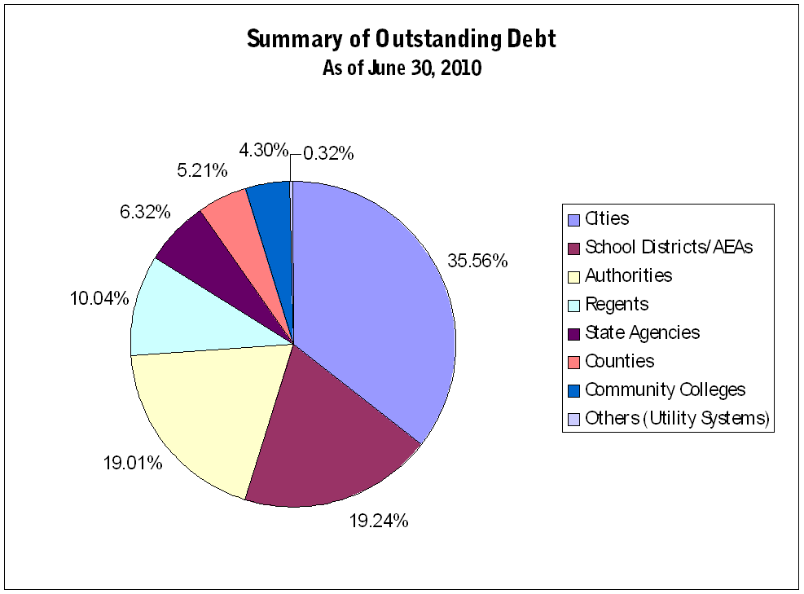

Figure 3

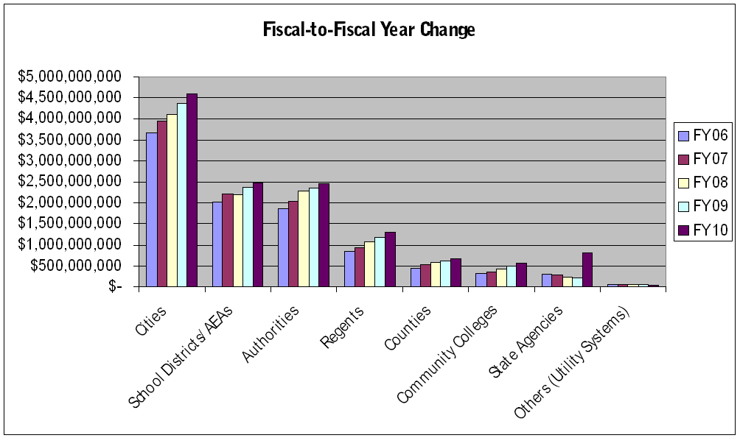

<http://www.treasurer.state.ia.us/finance/outstanding.cfm?ref=units>

Figure 10 Change in Debt Outstanding and Debt Capacity by City Size, 2010

|  |  |  |  |  |  |
| --- | --- | --- | --- | --- | --- |
| Table 1 |  | | |  |  |
| Vairable | Definition and source | | |  |  |
| GOTIF/population | Combination of General Obligation and TIF Debt on a per capita bases for 2010;  Sources: State Auditor Records, Des Monies,IA; population from  http://data.iowadatacenter.org/browse/places.html#Population-Estimates | | | | | | | | |
| GOTIF/ taxvaluation | Combination of General Obligation and TIF Debt as a percent of city taxable valuation for 2010;  Sources: State Auditor Records, Des Monies,IA; taxable valuation see below | | | | | | | | |
| pctowner occupied homes | Percent of Homes occupied in City(2010); Source: Census* | | | | | | | | |
| median home value | Owner-Occupied Housing Units: Median Value (Dollars) (Estimate)(2010)Source: Census* | | | | | | | | |
| median household income | Median Household income (Estimate) (2010) Source: Census* | | | | | | | | |
| pop65 | Percent of population in city above age 65 (2010); Source Census* | | | | | | | | |
| pop18 | Percent of population in city below age 18 (2010); Source Census* | | | | | | | | |
| population change2010-2000 | population change between 2000 and 2010 in a city; Source Census* | | | | | | | | |
| population | 2010 population; Source: Census* | | | | | | | | |
| mean commuting time | Mean Commute Time (minutes) for people in city(2010); Source: Census* | | | | | | | | |
| taxable valuation in city | Total TIF valuation without G&E Utilities in city on a per capita basis for 2010;  Source: Iowa Department of Management,  http://www.dom.state.ia.us/local/valuations/archive.html | | | | | | | | |
|  |  | | |  |  |
| Census: http://factfinder.census.gov/servlet/DatasetMainPageServlet?_program=ACS&_submenuId=datasets_2&_lang=en, 2005-2009 American Community Survey 5-Year Estimate | | | | | | | | | |
| Economic Research Services http://www.ers.usda.gov/Data/RuralUrbanContinuumCodes/, last updated Nov 3 2004 | | | | | | | | | |
|  | |  | |  |  |
| Table 2 Values are for Cities at or above 500 based on 2010 population | | | | | | | | |
|  | |  | |  |  |
| Variables | | Mean | | Standard Deviation |  |
| GOTIF/population | | 773.751 | 925.597 | |  |
| GOTIF/ taxvaluation | | 0.0230191 | 0..018122 | |  |
| pctowner occupied homes | | 0. 9013279 | 0. 0785174 | |  |
| median home value | | 96818.32 | 36322.06 | |  |
| Median household income | | 45828.87 | 11695.11 | |  |
| pop65 | | 0. 1826269 | 0. 070337 | |  |
| pop18 | | 0. 2457616 | 0. 0482633 | |  |
| population change2010-2000 | | 0. 0505503 | 0. 2200558 | |  |
| population | | 5072.28 | 15165.36 | |  |
| mean commuting time | | 18.57115 | 4.614411 | |  |
| taxable valuation in city | | 27444.93 | 20390.08 | |  |
|  | |  |  | |  |
|  |  | | |  |  |  |  |  |  |
|  | | | | | | | | | |
|  | | | | | | | | | |
|  | |  | |  |  |  |  |  |  |

|  |  |  |  |  |  |
| --- | --- | --- | --- | --- | --- |
| Table 3 Regression Results |  | Debt/Pop |  | Debt/Taxbase |  |
|  |  | 2010 |  | 2010 |  |
| Independent Variable |  |  |  |  |  |
|  |  |  |  |  |
| Taxable Valuation for 08/09/10 |  | 0.0228605*** |  | - |  |
|  |  | (0.0025694 ) |  |  |  |
| Percent of House Occupied |  | -0.0120093 |  | 0.0058069 |  |
|  |  | (505.8464) |  | (0.0113096) |  |
| Median Home Value |  | 0.0045195** |  | 0.0000000844* |  |
|  |  | (0.0022444) |  | (4.48e-08) |  |
| Median Houshold Income |  | -0.0066749 |  | -6.72E-08 |  |
|  |  | (0.0055107) |  | (1.36e-07) |  |
| Percent of Pop above age 65 |  | 676.5149 |  | 0.0139284 |  |
|  |  | (709.7194) |  | (0.0172638) |  |
| Percent of Pop below age 18 |  | 860.2315 |  | 0.0343631 |  |
|  |  | (933.6366) |  | (0.0233809) |  |
| Mean Commuting Time |  | -15.3786** |  | -0.000613*** |  |
|  |  | (7.655117) |  | (0.000192) |  |
| Pop percent difference 2000-10 |  | 449.5528** |  | -0.0024381 |  |
|  |  | (206.4797) |  | (0.0051436 ) |  |
| 2010 population |  | 0.0050622** |  | 0.00000016*** |  |
|  |  | (0.0060974 ) |  | (5.90e-08) |  |
| Constant |  | -84.06332 |  | 0.0123535 |  |
|  |  | (582.4424) |  | (0.0138346 ) |  |
| R squared |  | 0.4298 |  | 0.0713 |  |
| Note standard error in parentheses. ***,**, and * indicate significance at 1%, 5%, and 10% level, respectively. | | | | | |
|  |  |  |  |  |  |